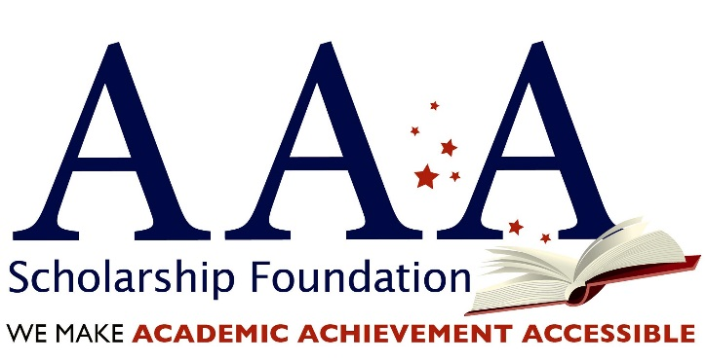

What Constitutes a Good Scholarship Organization

Because your tax redirection is such a gift to the low-income children it serves, it is crucial that you choose the right Scholarship Organization (SO) to be a good steward of your funds. Below is a list of simple questions that you should ask any organization before partnering.

- Does the SO have clean (“unqualified”) audits/reviews for the past three years? Most good non-profits should have their current audit posted on their website.
- Does the SO have a policy against nepotism and/or candidates for office on the payroll?
- What is their staff experience in running non-profit organizations?
- Does the SO have an outside party endorsement for good practices (i.e. Charity Navigator or GuideStar)?
- How many scholarships did the SO award for FY 2016 and what was the total dollar amount awarded?
- What percentage of the SO’s FY 2016 annual revenue was awarded to scholarships?
- What percentage of the SO’s FY 2016 revenues went to administrative costs?
- Does the SO give the scholarship to the child rather than a school (so that the scholarship is portable for that child should he/she need a different educational setting)?
- Have the SO explain how they define 'low-income' or 'economically-disadvantaged'.
- Does the SO ban the practice of stacking in Arizona? (Note: stacking is a practice used by many SO’s that allow one child to receive scholarships from multiple SO’s, so there is no way that the Dept. of Revenue to track how many or the amount of scholarship funds that a child receives.)

AAA is the only state approved scholarship organization in the country that is approved to manage state corporate tax credit scholarship programs in six states. And many other things make us distinct. The AAA Scholarship Foundation:

- has been awarded the prestigious Guide Star Platinum Seal, demonstrating the highest level of good management practices in a non-profit organization.
- Awards scholarships directly to families - not schools.
- Awards scholarships solely to qualifying low-income, disabled and/or displaced students.
- Awards scholarships for at least a 3-year term in states that allow multi-year commitments – we believe that the continuity of an educational setting is important for children to succeed.
- Is managed by the nation’s leading state corporate tax credit scholarship program professionals with nearly 20 years of experience successfully administering programs.
- Has a CPA on-staff to ensure that your tax questions are answered correctly and to ensure timely and accurate reporting.
- Limits our overhead to 4.14 percent for administrative funding (3 percent in Florida).

